Handout no. 3

|  |  |
| --- | --- |
| **Name** |  |
| **Reg. No** |  |
| **Marks/Grade** |  |

**EXPERIMENT # 3**

**Implementation of transmission lines in Power world Simulator (PWS) and Y-Bus calculation in PWS**.

**Objective:**

At the end of this lab session students will be able to

* To design Electric Power Transmission system in in Power World Simulator.
* To observe power flow in power System.
* To construct Y-bus of system.

**Introduction:**

Power World is a great and “powerful” utility for solving power flows. Solving a power system is a little different from circuit analysis. Instead of being given voltages at certain nodes or impedances, you are often given load and generator powers. This makes solving the circuit difficult to do by hand, but easy using a tool like Power World. Most utilities use Power World or similar programs for solving their systems, such as PSS/E.

Adding Power World to your Start Menu:

1. Add Power World to your start menu. In computer , click Start > All Applications >Add Applications to Start Menu, and search for Power World.

2. Launch Power World**.**

**Mode of Operations:**

There are two modes of operations.

* Run Mode
* Edit Mode

**Edit Mode of Operation:**

In edit mode of operation, the network is designed. All changings of network is done in this mode of operation. The window of draw network is in Edit mode of operation in which options of drawing all components are presents.

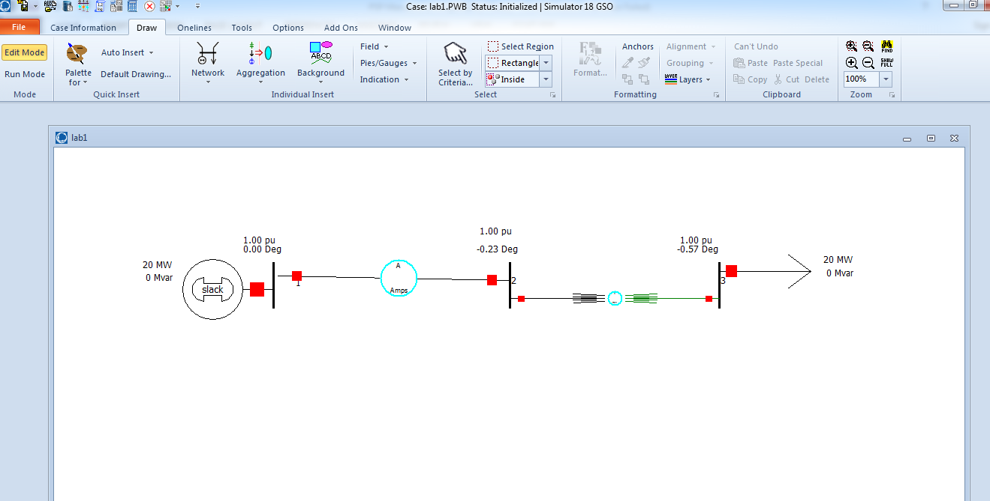

Figure No: 1

**Run Mode:**

In run mode system power flow is analysed. Active and reactive power at each bus is analysed. All fault analysis can be done in run mode of operation.

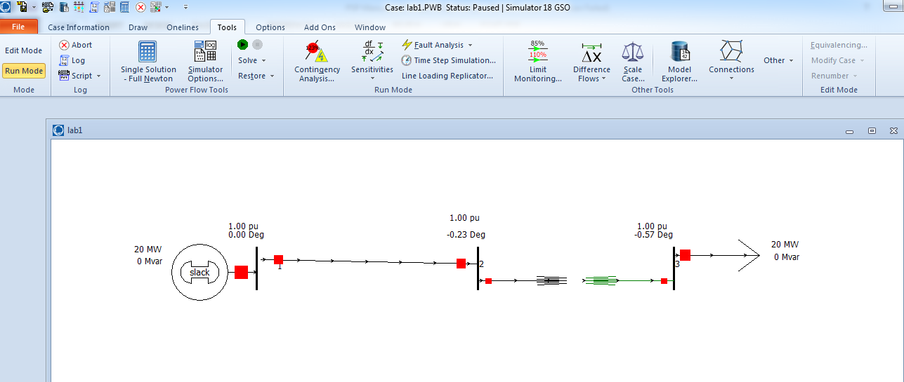

Figure No: 2

**Inserting a Bus:**

* The most important component of the power system model is the bus. Buses are used to represent the junction points in the power system where several devices are connected. In building a power system model using simulator you will draw buses onto the one-line diagram, attach devices such as generators and loads to the busses and connect different busses together with transmission lines and transformers. To insert bus
* Select **Network > Bus** from the individual insert ribbon group on the draw ribbon Tab. This prepare simulator to insert bus.

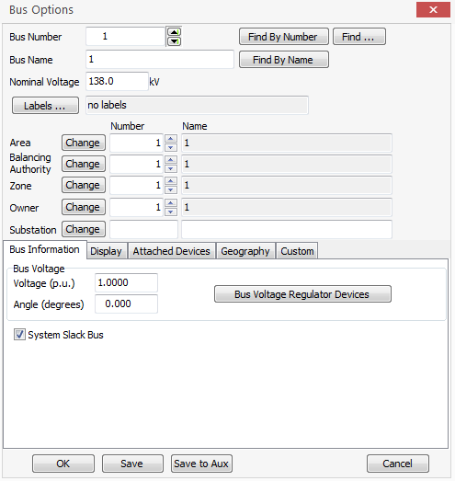

**Insert a Generator:**

* Next, we are going to attach generator to the bus. Generators may be inserted in a similar manner to insert bus.
* Select **network > generator** from the individual insert the ribbon group on the draw ribbon tab.
* Left click the bus on the one-line diagram to which you want to attach the generator. The generator option dialog will automatically open. The dialog is used to specify the new generator unit identifier, display size, orientation, MW output and limits, reactive power limits, set point voltages and cost model.
* Select the display information tab. The orientation field is used to specify the direction the generator will extend from the bus. The Anchored checkbox forces the generator to move with its specified bus when repositioning the bus on the one-line.

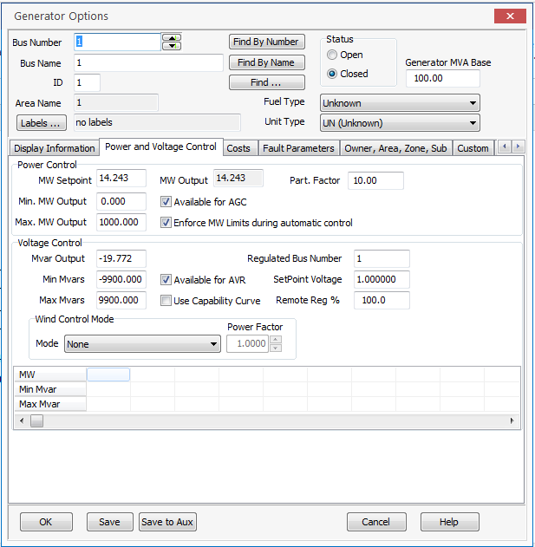

**Insert a Load:**

* Select network > Load from individual insert ribbon group on the draw ribbon tab.
* Left click in the centre of the bus. The load option dialog box automatically opens the constant power MW and MVAR fields confirm that load is 200 MW and 100 MVAR. In addition to constant power loads, simulator also allows the modelling of voltage dependent loads.
* Select up in the orientation field under the load information tab to make the load point up. Verify that the anchored box is checked to force the load to move with the selected bus. Its orientation can be changed.
* Click OK to accept the default values for all remaining fields close the load option dialog and insert the load. A circuit breaker symbol is automatically included with each load.

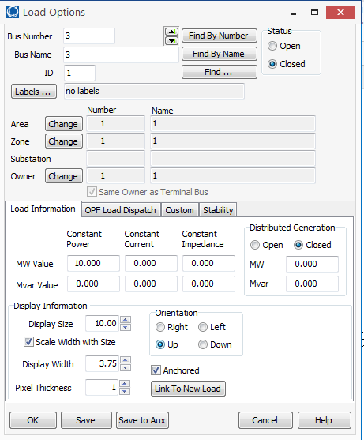

**Inserting a Transmission line:**

* Select **Network> Transmission** line from the individual insert ribbon group on the draw ribbon tab.
* Left click at the point where you want the new line to originate. This point is usually located on one of proposal lines terminal busses. For this example, originate the line at the bus.
* Transmission lines and transformer are drawn as series of line segments. Without holding down the mouse button drag the mouse up. Notice that a line segment connected to the point of origin will follow your mouse movement. To terminate a final line segment and conclude drawing line double click the left mouse at termination point.
* Enter your desire value of resistance and reactance values.

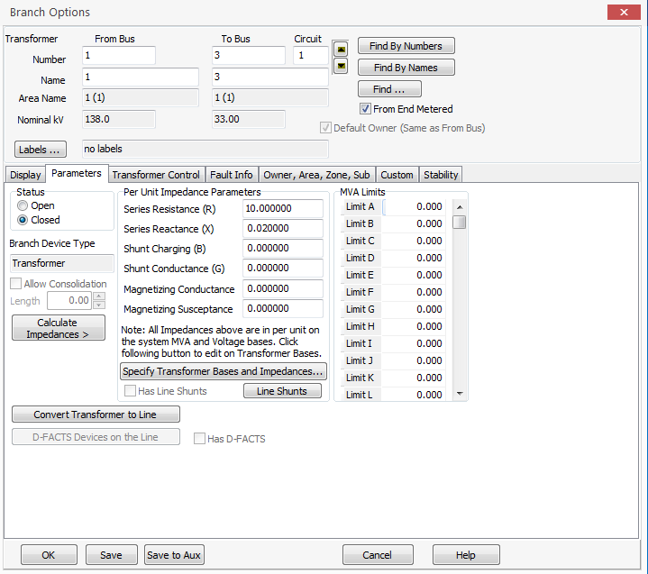

**Lab Task:**

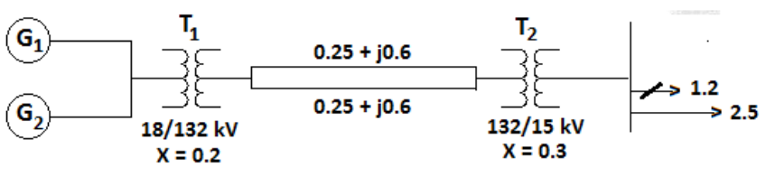

Generator 1 MW output: 30, -5 MVar

Generator 2 MW output: 35, -5 Mvar

Load 1: 25 M, Load 2: 20 MW and 5 Mvar

A power system on 100 MVA base is shown in fig. below; the generators real power, real and reactive  
loads, transformer reactance and transmission line parameters are all shown in per unit. Simulate the  
system using **Power World Simulator** and show the following quantities.

* Sending end voltage in per unit and in kV
* Receiving end voltage in per unit and in kV
* Y-bus

Note:

* Values of Impedance must be put in per unit system.

**Part b:**

Determine the amount of shunt compensation at the receiving end such that the receiving end voltage  
remains within 0.99 to 1.01 per unit

Fig. below shows the one-line diagram of a simple three-bus power system with generation at bus 1.



